Create angular Application: ng new application2

Move to app: cd application2

Open the app in vs code by executing > code . commamd

Run app by using: ng serve command : check output on browser: localhost:4200

Include bootstrap in your app open index.html

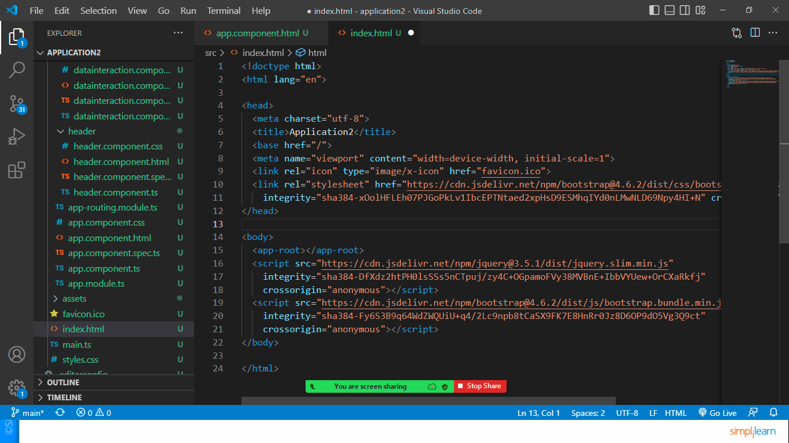

Create component called header> ng g c header

Open header.component.html file

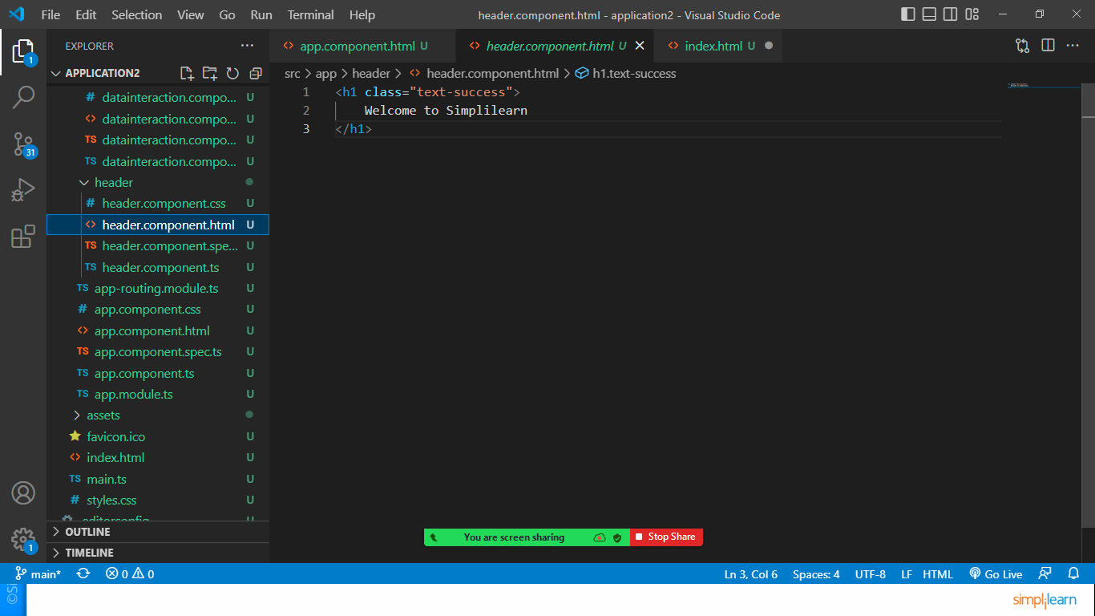

Let’s include component in app.component.html

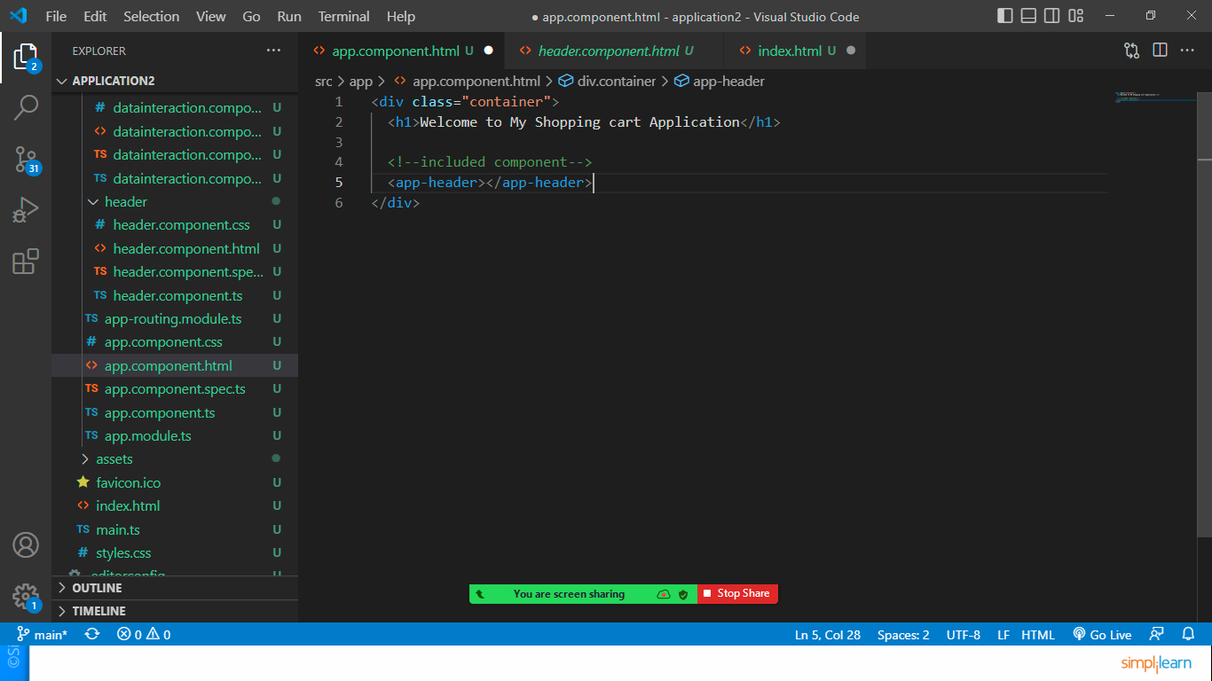

Let’s do the data interaction:

Again create new component: ng g c datainteraction

Update app.component.html file

<div class="container">

  <h1>Welcome to My Shopping cart Application</h1>

  <!--included component-->

  <app-header></app-header>

  <app-datainteraction></app-datainteraction>

</div>

Let’s declare a variable in datainteraction.component.ts file

export class DatainteractionComponent {

    link:string="https://www.google.com"

    target:string="_blank"

    imgurl:string="./assets/images/nature.jpg"

    h:number=300

    w:number=500

}

Declare the above mentioned variables

Let’s access this variable in html file using property binding

Open datainteraction.component.html file

<h3>Property Binding</h3>

<hr>

<a [href]="link" [target]="target">Click Here to Open Google</a>

<br>

<img [src]="imgurl" [height]="h" [width]="h">

Interpolation: print variables value directly in browser

Declare a variable called message in datainteraction.component.ts file

message:string="Welcome to interpolation"

to print in html use double curly braces

<h3>Interpolation</h3>

<hr>

<h4>{{message}}</h4>

Display List of Data in component

Create component

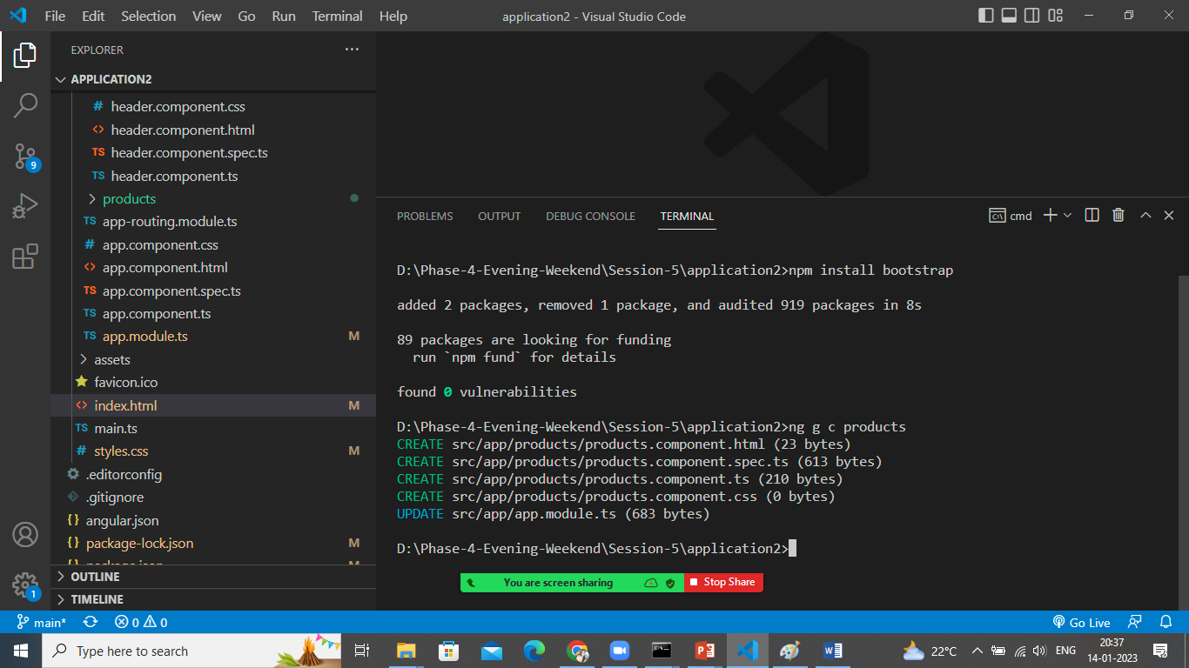

Open products.component.ts file and create some data

export class ProductsComponent {

  products=[

    {id:1,name:"Pencil",available:"20-01-2023",price:5,rating:4.5},

    {id:2,name:"Pen",available:"26-01-2023",price:10,rating:4.7},

    {id:3,name:"Eraser",available:"20-02-2023",price:3,rating:4.2},

    {id:4,name:"Scale",available:"29-01-2023",price:15,rating:4.1}

  ]

}

Let’s display them on products.component.html

<h3>Product Component</h3>

<table class="table table-hover table-bordered">

    <thead>

        <tr>

            <th>Id</th><th>Name</th><th>Available</th><th>Price</th><th>Rating</th>

        </tr>

    </thead>

    <tbody>

        <tr *ngFor="let p of products">

            <td>{{p.id}}</td>

            <td>{{p.name}}</td>

            <td>{{p.available}}</td>

            <td>{{p.price}}</td>

            <td>{{p.rating}}</td>

        </tr>

    </tbody>

</table>

Let’s add this product component in app.component.html

<div class="container">

  <h1>Welcome to My Shopping cart Application</h1>

  <!--included component-->

  <app-products></app-products>

  <!-- <app-header></app-header>

  <app-datainteraction></app-datainteraction> -->

</div>

Inside this Let’s do some styling of data using class binding

Open products.component.css file and add below class

.stock{

    background-color: green;

    color: white;

    font-weight: 700;

}

Nor let’s do some dynamic class binding by updating products html file

 <td [class.stock]="true">{{p.available}}</td>

Change the value to false and also check

Style binding directly in html file

<td [style.font-weight]="700">{{p.rating}}</td>

Check the output

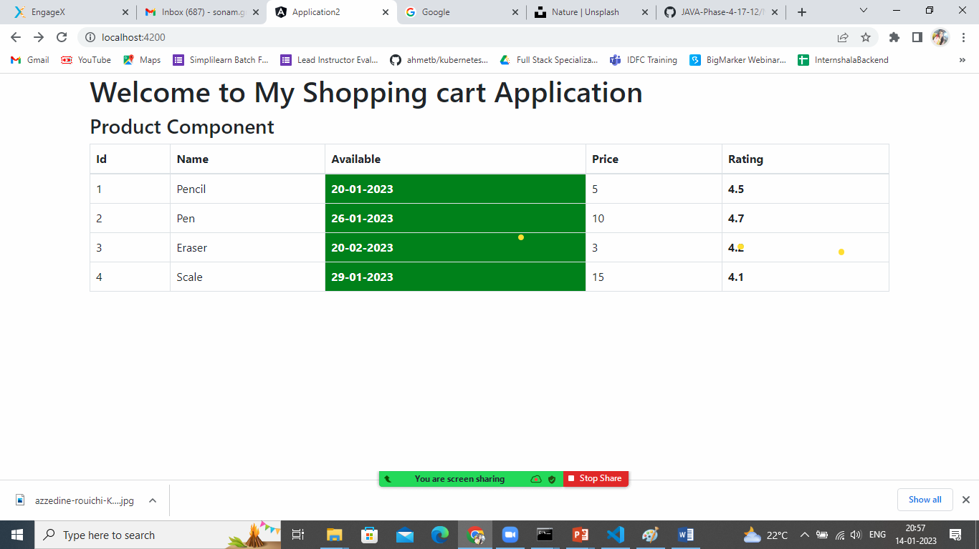

Event Binding: bind data from html to ts

So let’s create one method and one variable named flag in products.component.ts file

flag:boolean=false;

  show():void{

    this.flag=!this.flag

    console.log("You have clicked on this button "+this.flag)

  }

Let’s call this method by clicking on button and according to the flag condition display data

Open products.component.html file

<button class="btn btn-primary" (click)="show()">Click Here</button>

<p *ngIf="flag">Welcome to my Paragraph</p>

Check the o/p by clicking button.

Let’s do the 2way binding

Pass data from html to ts as well as ts to HTML

That we can do by using ngModel which is a part of FormsModule.

First of all let’s import forms module in app.module.ts

imports: [

    BrowserModule,

    AppRoutingModule,

    FormsModule

  ],

After this let’s declare variable in ts file.

name:string="Sonam Soni"

in html file let’s do 2 way binding

Enter your name:<input type="text" [(ngModel)]="name">

<h5>My name is {{name}}</h5>

You can try editing text field and at the same time you can see the reflection in that value which is displayed below.